**MVP: MyPictureBank**

………………………………………………………………….

HOME PAGE.

Signup/Demo Form

User clicks button from home screen and is pushed tot eh form to enter a vaid email, username and password.

If user enters an email already taken at sign up, they are alerted that the email is invalid and already established, and then directed to re-enter a new set of credentials.

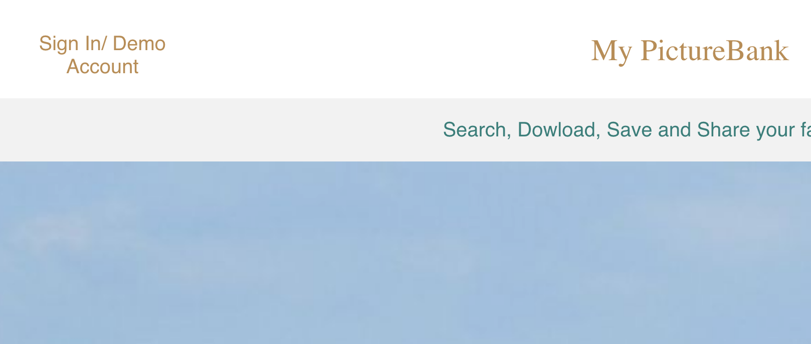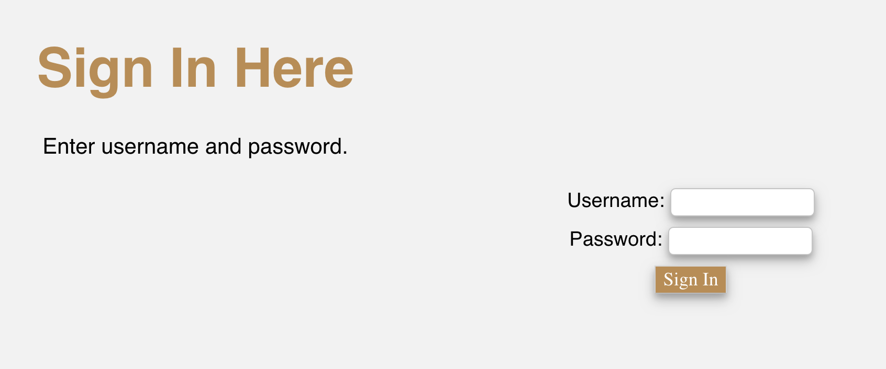

………………………………………………………………….

ACCOUNT PAGE

Upload Pictures

User clicks upload button and a window opens to allow them to upload photos from their client-side.

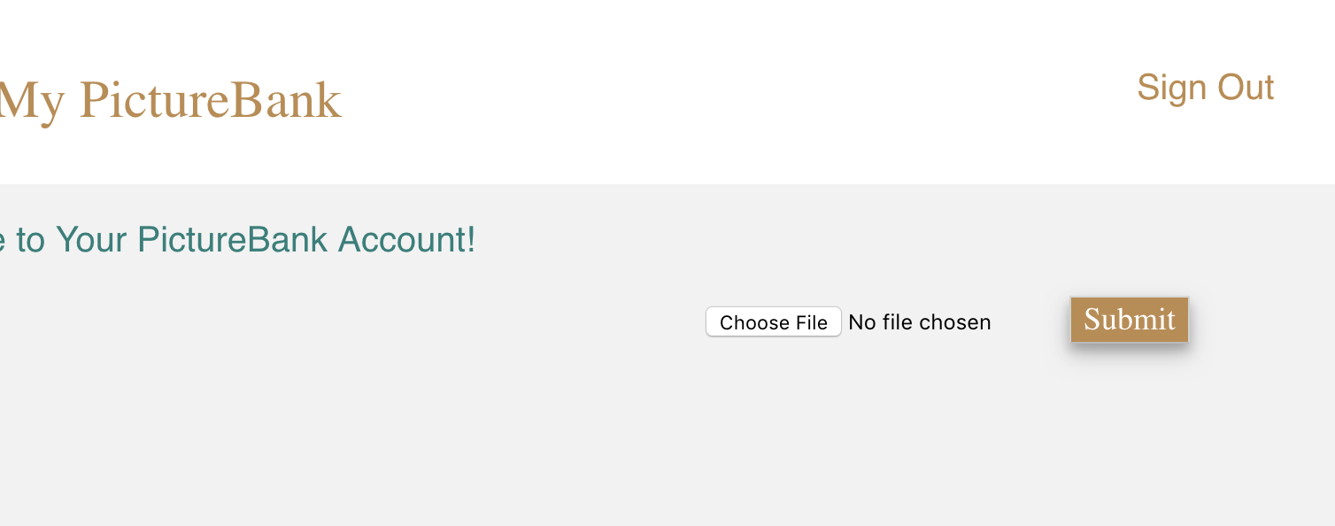

ACCOUNT PAGE

Adding Captions

User views uploaded photo and can delete or add a caption to the photo using the buttons as illustrated below:

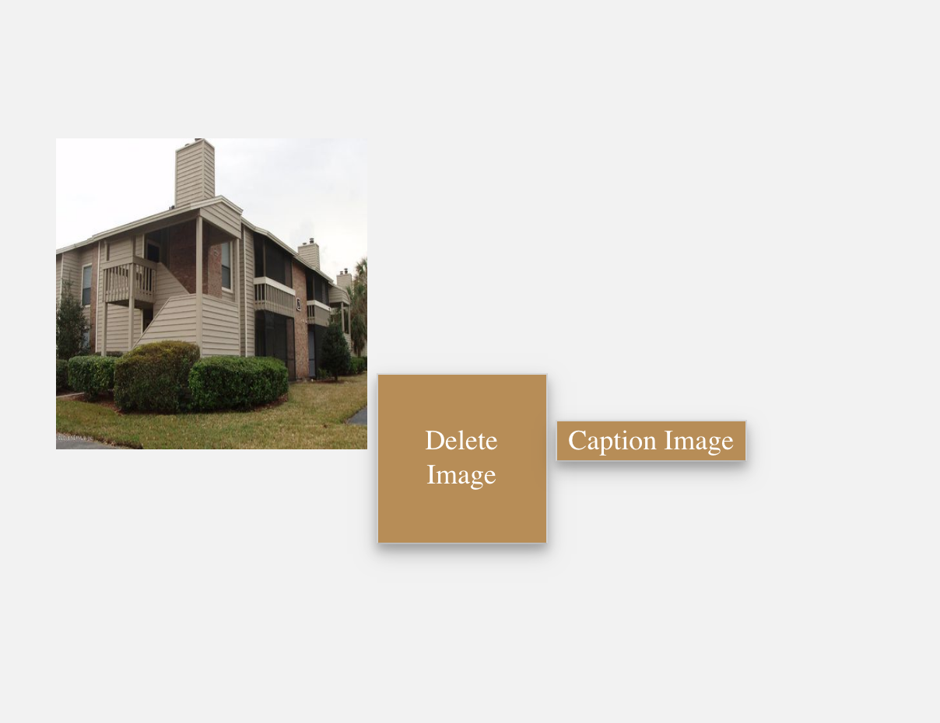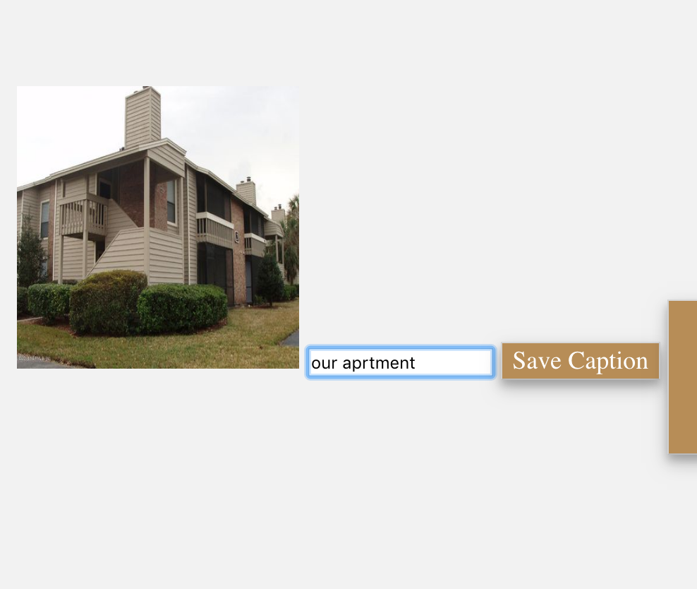

Users will be able to read and review the updated image with its caption as illustrated below:

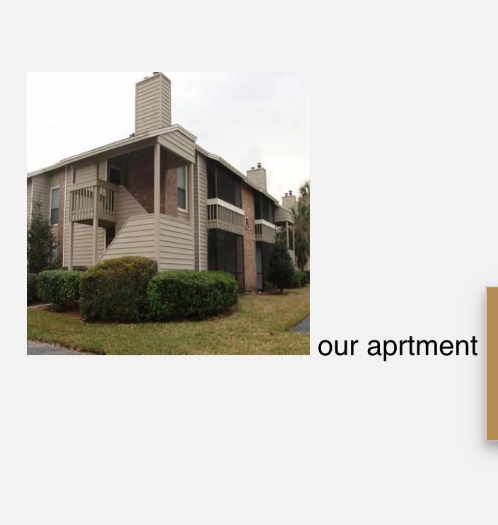

ACCOUNT PAGE:

Log Out

Users will be able to click the Sign Out button.

Users will be directed back to the home page.

